**Project Design Phase-II**

**Data Flow Diagram & User Stories**

| Date | 03 October 2022 |
| --- | --- |
| Team ID | PNT2022TMIDxxxxxx |
| Project Name | Project - xxx |
| Maximum Marks | 4 Marks |

**Data Flow Diagrams:**

A Data Flow Diagram (DFD) is a traditional visual representation of the information flows within a system. A neat and clear DFD can depict the right amount of the system requirement graphically. It shows how data enters and leaves the system, what changes the information, and where data is stored.

**DFD Level 0 (Industry Standard**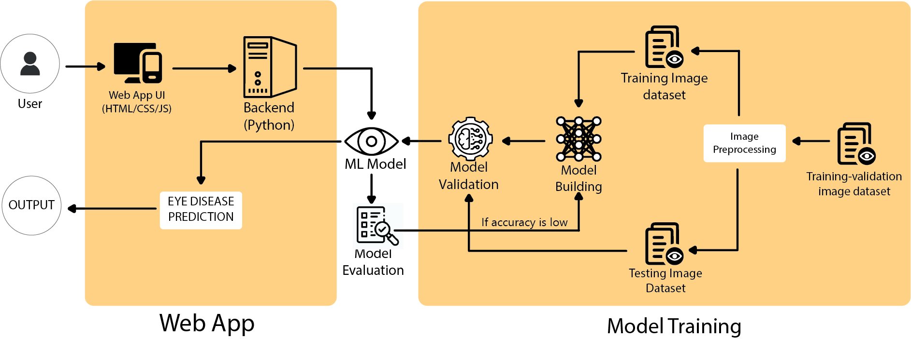

**FLOW**

1. User enters the test image of the retina.
2. The image info is converted into array format in the backend.
3. The array data is passed through the ml model.
4. The ML model returns the probability of detecting the following from the input image : glaucoma', 'cataract', 'normal', 'diabetic_retinopathy’.
5. The category with highest probability is printed as predicted output.

**User Stories**

Use the below template to list all the user stories for the product.

| **User Type** | **Functional**  **Requirement**  **(Epic)** | **User Story Number** | **User Story / Task** | **Acceptance criteria** | **Priority** | **Release** |
| --- | --- | --- | --- | --- | --- | --- |
| Customer  (Desktop) | Web hosting | USN-1 | As a user, I am able to access the web app from the desktop. It is working. | I can access the portal. | High | Sprint 1 |
| Customer  (Desktop/Mobile) | POST/GET request | USN-2 | As a user, I am able to select an image of my choice | The image of my choice is being displayed on web portal | High | Sprint 2 |
| Customer  (Desktop/Mobile) | Python Script | USN-3 | As a user, I am able to get a prediction result after uploading the retina image | The system is functional end to end. | Moderate | Sprint 3 |
| Customer  (Mobile) | Web hosting | USN-4 | As a user, I am able to access the web app from my smartphone. | I can access the portal. | High | Sprint 1 |
| Customer  (Desktop/Mobile) | Trained Machine Learning model | USN-5 | As a user, I am able to get varied predicted values as per my input. | The prediction is able to detect the disease with high accuracy. | High | Sprint 4 |
| Admin | ML Model | USN-6 | As an admin, I am able to edit changes in the ML model. | Trainable model in .ipynb file | Low | Sprint 5 |
| Admin | UI/UX (HTML/CSS/JS) | USN-7 | As an admin, I am able to modify UI/UX as per user convenience. | Editable HTML, CSS, JS | High | Sprint 6 |